|  |  |
| --- | --- |
| **15th MARCH, 2021**  Logo silhouette.JPG  **Post: P.O. Box 1898, Aitkenvale.**  **Qld.4814 Web :** [**www.jazztownsville.com**](http://www.jazztownsville.com)  **Email:** [**townsvillejazz@icloud.com**](mailto:townsvillejazz@icloud.com)  **Executive Committee:**  **President**  **Bob Passmore 0438 093 503**  **Vice President**  **Jeremy Hawker 0408 959 979**  **Treasurer**  **Phil McIntyre 0412 408 061**  **Secretary**  **Coralie Costigan 0431 618 618**  **Committee Members:**  **Rob Bray Bob Spillane**  **Julie McIntyre Reg Braun**  **Sarah Lane Leonie Dunne**  **Cecilia Rocha**  C:\Users\Coralie\AppData\Local\Microsoft\Windows\INetCache\IE\XEOHF19V\whats-next-1462747_1280-320x160[1].png  **@ Fish Inn on Sundays**  **5pm to 8 pm**    28th March  Reg Braun Quintet  See poster on following page | 28th March, 2021  **Return of RB5**  **Reg Braun Quintet**  **Featuring**  **Mark Wyer on Piano**  **Reg Braun on Drums**  **Gavin Forno on Bass**  **Sara Shaw on Vocals**  **John Garland on Keyboard**  **BOOKINGS ARE ESSENTIAL**  **As we have been fully booked for the last couple of Jazz sessions, could I please suggest that you make your**  **booking as soon as possible**  **so that you will not be disappointed?**  **Please contact us on the Club’s email** [**townsvillejazz@icloud.com**](mailto:townsvillejazz@icloud.com)    **OR Phone Coralie on 0431 618 618** |

|  |  |  |
| --- | --- | --- |
|  | |  |
|  |  | |
|  | |  |
|  | |  |

M

**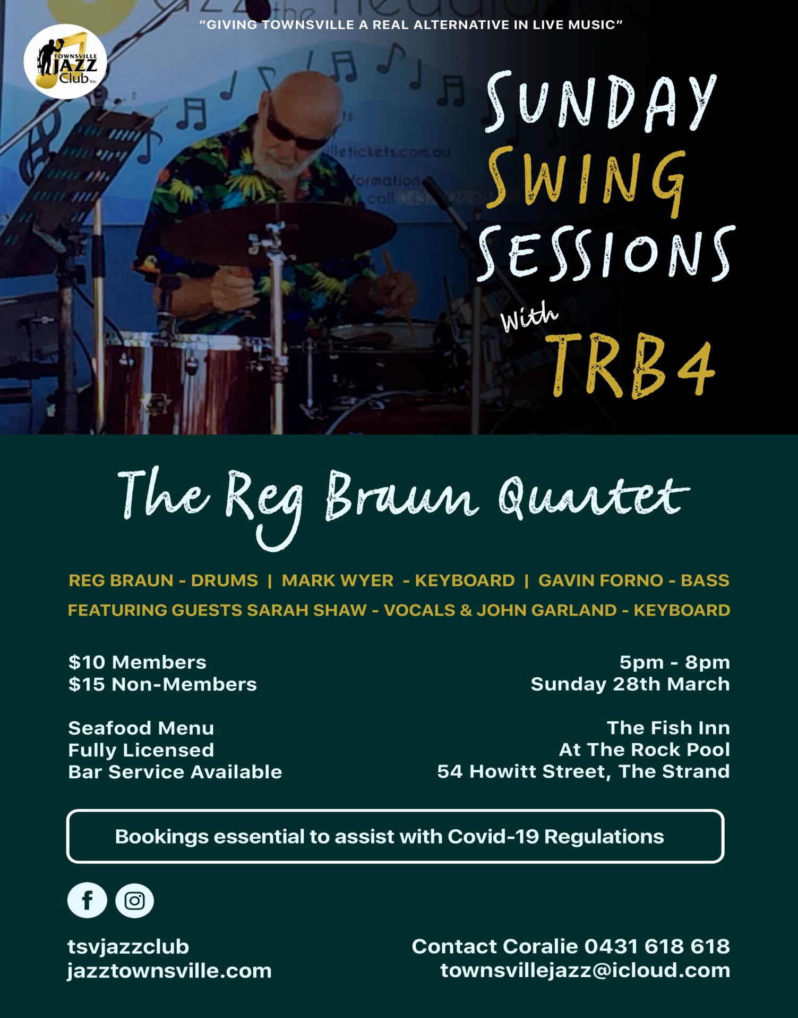**

Some